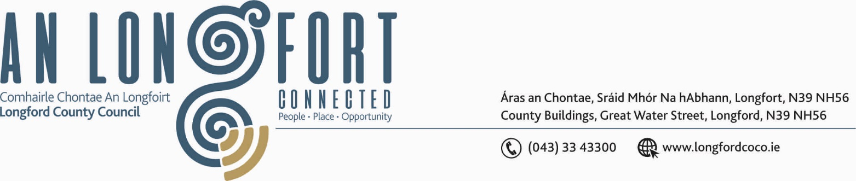

LONGFORD MUNICIPAL DISTRICT

Please note venue of Meeting –
Council Chamber, Aras an Chontae, Great Water Street.

16th January 2020.

To: Each Member of Longford Municipal District.

Dear Member,

You are requested to attend Meeting of Longford Municipal District to be held in the
Council Chamber, Aras an Chontae, Great Water Street, Longford on Wednesday,
22nd January 2020 at 4.30 p.m. to transact business, as set out on the Agenda hereunder.


Yours sincerely,

_______________
Anne Lee,
Meetings Administrator.

AGENDA

Prayer before meeting.

- Confirmation of Minutes of Longford Municipal District Meetings held on the
27th November 2019 – copies enclosed.

- Matters arising from Minutes.

- Declaration of Interest by Members.

- Management Report - to follow.

- Consideration and adoption of Draft Municipal District Report for inclusion in
Longford County Council 2019 Annual Report – enclosed.

- Recommendation from the Placenames Sub-Committee -

Notice of Motion submitted by Councillor Joe Flaherty to Longford Municipal District -
“That we forward to the next meeting of the Place Names Committee a recommendation that they provide a name for the 'street' of mainly commercial premises that backs onto the Shopping Centre carpark from Chapel St. A number of the units recently changed hands with new ventures planned and as part of the planned rehabilitation of the car park area, it would be good if this 'street' finally gets a name.”
Recommendation of Placenames Sub-Committee - Chapel Way

- Consideration of Adoption of Part 8 Report (Planning and Development Act 2000
(as amended) and Planning and Development Regulations 2001 (as amended) in respect
of the construction of an Amenity Trackway through part of the Bog in the Townlands of
Knappogue (Longford BY), and Cloonard (Longford BY), County Longford
- details enclosed.

- Consideration of Adoption of Part 8 Report (Planning and Development Act 2000
(as amended) and Planning and Development Regulations 2001 (as amended) in respect
of the reconstruction of existing St. Mel’s Road Boundary Wall at St. Mel’s College,
Townparks and Deanscurragh, Longford Town, Co. Longford.
- details enclosed.

- Notices of Motions, submitted by Councillors, as listed hereunder –

Councillor John Browne.

“I call on Longford County Council to have a house numbering system put in place at College Park and Templemichael Glebe similar to that at the Laurels Longford”

Councillor Gerry Warnock.

“I am proposing that Longford Municipal District erect a Reflection Bench in The Mall (Albert Reynolds Peace Park) to honour the memory of former Councillor Michael Nevin, who recently passed on to his eternal reward. Through his work as the FAS Supervisor, Michael was instrumental in developing The Mall into the beautiful offering we are privileged to have today and it’s appropriate that we honour this.”

Councillor Martin Monaghan.

“I would like to see an upgrade of existing lighting and improvements to signage at the pedestrian crossing on the Killashee Road between the Aldi and Super-Valu Stores.
As this is a very busy thoroughfare and currently poses serious health and safety risks to all users.”

Councillor Seamus Butler.

“That Longford Municipal District consider introducing a Business Improvement District (BID) in the retail core of Longford Town.”

- Correspondence.- enclosed

(a) Letter dated 3rd January 2020 received from the Office of the Minister for Justice and Equality regarding funding for CCTV in Longford town.

- A.O.B.



